HandFrame AI: Gesture-Framed Capture and Real-Time Image Stylisation
Image and Video Processing, Mini-Project Report
Item | Details
Course | Image and Video Processing (IVP)
Student names | Hussain Rampurawala, Jayendra Singh Rawat, Daksh Mehta
Roll numbers | F013 (ID 70022400076) for Hussain Rampurawala; [add] Jayendra Singh Rawat; [add] Daksh Mehta
Programme / Semester | B.Tech Computer Engineering / Semester V
Faculty name | [add faculty name]
Institute / Department | SVKM's NMIMS / STME
Academic year | 2026-27
Submitted | 16 October 2026

Abstract
Abstract. Capturing and restyling a photograph normally needs a touch screen, a mouse or a separate editing application. This project presents HandFrame AI, a desktop application that lets a user build a floating camera frame in mid-air with both hands, capture the framed region with a pinch, and restyle it instantly in one of 16 artistic styles. Each webcam frame is processed by a pretrained Media Pipe Hand Landmarker (palm detection plus 21-keypoint regression, up to two hands). The landmarks are smoothed with a One Euro filter. The thumb and index fingertips of the two hands form the four corners of a quadrilateral, which is validated (size, convexity, aspect ratio) and ordered. A pinch is detected from a scale-invariant thumb-to-index distance ratio with hysteresis thresholds (on below 0.25, off above 0.40). On a pinch the framed region is rectified with a perspective transform, styled off the main thread by classical OpenCV stylisers (or, optionally, by FLUX.1 image-to-image), and warped back into the live video with a border and soft shadow. In our measurements on a 2-core CPU, the 16 OpenCV styles ran in a median of 15 ms per 512 px capture (0.9 ms to 425 ms), hand-landmark detection took about 15 ms per 720p frame (measured on a frame without a hand), the One Euro filter cut static landmark jitter by 62% (1.89 px to 0.71 px in a simulation), and hysteresis reduced pinch-state flips from 50 to 2 on a noisy signal. The main limitations are dependence on lighting and hand visibility, and that the quality of the optional AI styling depends on a GPU.
Index Terms: hand landmark detection, gesture interaction, perspective transform, One Euro filter, image stylisation, OpenCV, MediaPipe, human-computer interaction.

I. Introduction

A. Background
Photographing something, cropping it and applying an artistic filter normally takes several separate steps: aim the camera, press a button, open an editor, choose a filter. Hand gestures are a more natural way to give such commands. Framing a scene with two hands, as a photographer or film director does with an "L" shape, already tells the viewer what is inside the shot, and a pinch can act as the shutter. Earlier gesture systems needed data gloves, depth cameras or coloured markers [10]. Lightweight convolutional networks can now estimate a full hand skeleton from a single RGB webcam frame in real time [1], [2].
Style transfer and image stylisation are equally familiar. Classical image processing can turn a photograph into a pencil sketch, cartoon, oil painting or thermal image in a few milliseconds using filters and colour mapping [5], [6], and modern diffusion models such as FLUX.1 can restyle an image far more convincingly when a GPU is available [11].

B. Relevance of the problem
- Touch-free creative interaction: the user needs no mouse, keyboard or touch screen to capture and restyle an image.
- Education: the application demonstrates geometric transforms, filtering, thresholding and deep-learning detection in one working system.
- Accessibility and cost: a standard webcam is nearly universal, while depth cameras and VR controllers are not.
- Privacy: hand tracking and the default OpenCV styles run entirely on the local machine, so no video leaves the computer.

C. Role of image and video processing
The whole interaction depends on image and video processing [5], [6]. The camera supplies a continuous stream of frames. Each frame must be mirrored and colour-converted, analysed to find the hands and their 21 keypoints [1], and reduced to a few robust features: four fingertip positions and a pinch ratio. Across frames the system performs video processing: it tracks the hands over time, smooths jitter with a One Euro filter, and debounces the pinch using hysteresis. The framed region is then rectified with a perspective (homography) transform, restyled with filters, and warped back into the live video. Without these steps the raw network output is too noisy to control anything precisely.

D. Motivation
We chose this project because it connects the classical topics of the course (colour spaces, geometric transformations, filtering, thresholding, edge detection, feature extraction and temporal filtering) with a modern deep-learning hand detector, and produces something visibly interactive. It also poses a real engineering question: how can a stream of noisy keypoints be turned into a stable, low-latency "frame and capture" action that feels natural to a user?

II. Problem Statement and Objectives

A. Problem statement
- Capturing a region of a scene and applying an artistic style usually needs a mouse, a touch screen or a separate editor, which is indirect and slow.
- Raw hand keypoints are noisy, change with the user's distance from the camera, and flicker from frame to frame, so they cannot be used directly as commands.
- The problem is therefore: using only a standard RGB webcam, detect and track both hands in real time, derive a stable four-cornered frame and a reliable pinch trigger from them, and use these to capture and restyle the framed region instantly.

B. Objectives
The objective of this project is to detect and track a user's hands in a live webcam video, extract landmark-based geometric features (frame corners and pinch ratio), and use them with image and video processing techniques to capture a perspective-corrected region and restyle it in real time.
- Hand detection and landmark extraction: locate up to two hands in each frame and extract 21 keypoints per hand with a pretrained palm-detection plus landmark model.
- Gesture feature design: build a four-corner frame from the thumb and index fingertips of both hands, and a scale-invariant pinch ratio for the capture command.
- Temporal stabilisation: suppress jitter and false triggers with a One Euro filter, pinch hysteresis, a short grace period for lost hands and a capture cooldown.
- Geometric capture and compositing: rectify the framed region with a perspective transform and warp the styled result back into the live video with a border and shadow.
- Instant stylisation: provide 16 artistic styles using classical OpenCV filters, executed on a worker thread so that the video never freezes, with an optional FLUX.1 image-to-image backend.
- Evaluation: measure style run times, rectification accuracy, filter jitter and pinch stability, and report the limitations.

III. Scope of the Project

A. What the project covers
- Real-time capture of a single front-facing webcam stream (default 1280x720, camera index selectable, selfie-view mirroring on by default).
- Detection and tracking of up to two hands, 21 landmarks each, using the pretrained MediaPipe Tasks Hand Landmarker (inference only).
- One Euro smoothing of landmarks and of the frame quadrilateral, with a 0.3 s grace period before a lost hand or frame is discarded.
- A two-hand "L" frame: the thumb tip and index tip of each hand give four corners, which are ordered (top-left, top-right, bottom-right, bottom-left) and validated.
- Pinch-to-capture with hysteresis and a 1 s cooldown; the frame is held steady from the last clean quadrilaterals while the fingers close.
- Perspective rectification of the framed region (up to 512 px on the long side) and perspective warp-back with border and drop shadow.
- 16 style presets, each with an instant OpenCV stylizer and a FLUX.1 prompt, a worker thread with result caching, and keyboard control (style change, save, reset, quit).
- A heads-up display showing FPS, status, active style and hints.

B. What the project does not cover
- Training or fine-tuning any neural network. The hand model is a pretrained component, and FLUX.1 is optional and used as is.
- Recognition of arbitrary gestures or dynamic gestures (swipes, circles). Only the two-hand frame and the pinch are used.
- Depth sensing, stereo cameras or tracking more than two hands.
- Video (moving) capture: a capture is a single still frame.
- A formal user study or a labelled gesture dataset.

C. Type of images and videos used
Live colour (BGR) video from a laptop or USB webcam, requested at 1280x720. For evaluation, because no camera was available in the test environment, we used a public sample portrait for style tests, synthetic checkerboard frames for geometry tests, and simulated landmark trajectories with Gaussian noise for the filter and pinch tests (Section IV).

D. Application domain
Human-computer interaction and creative media: touchless photo booths, exhibitions and classroom demos, social-media content creation, and presentations in which the speaker captures and restyles the view without touching a device.

IV. Dataset / Input Description
The system works on live video and has no training dataset of its own. It uses a hand model pretrained by Google [4]. The Hand Landmarker was trained by its authors on about 30,000 manually annotated real-world images plus rendered synthetic hands [1]. For each detected hand it outputs 21 landmarks with normalised x, y (0 to 1 relative to the frame), a relative depth z, and a handedness label with confidence. In this project only x and y are used. Table I lists the inputs used at run time and in our evaluation.
TABLE I. Inputs used by the system and in the evaluation.
Input | Source | Count | Resolution | Format
Live webcam stream (runtime input) | OpenCV VideoCapture, camera 0 | 1 stream | 1280x720 requested | BGR video frames, about 30 fps
Hand Landmarker model | Google MediaPipe, float16, v1 (bundled in models/) | 1 | Internal 192/224 px crops | .task file, 7.8 MB
Sample portrait (style tests) | scikit-image sample data (public domain NASA photograph) | 1 | 512x512 | RGB image
Synthetic camera frame (geometry tests) | Generated with OpenCV: checkerboard plus text | 1 | 1280x720 | BGR image
Simulated landmark track (filter test) | Sinusoidal motion plus Gaussian noise, sigma = 2 px, 240 frames at 30 fps | 1 | n/a | Array of (x, y)
Simulated pinch-ratio signal (hysteresis test) | Piecewise ratio plus Gaussian noise, sigma = 0.03, 400 frames | 1 | n/a | Array of floats
Blank synthetic frame (detector timing) | Smoothed random noise | 1 (repeated 40 times) | 1280x720 | BGR image
The landmark numbering used by the code (0 = wrist, 4 = thumb tip, 8 = index tip, 9 = middle-finger MCP joint, 12, 16, 20 = other fingertips) follows the MediaPipe convention [1], [4]. The application uses landmark 4 and 8 of each hand for the frame, and landmarks 0, 4, 8 and 9 for the pinch ratio.

V. Methodology / Proposed Approach
The application runs one main loop, once per captured camera frame. Fig. 1 shows the complete processing chain. Styling jobs are the only work taken off this loop: they run on a single worker thread so that the live video never waits for a slow style.
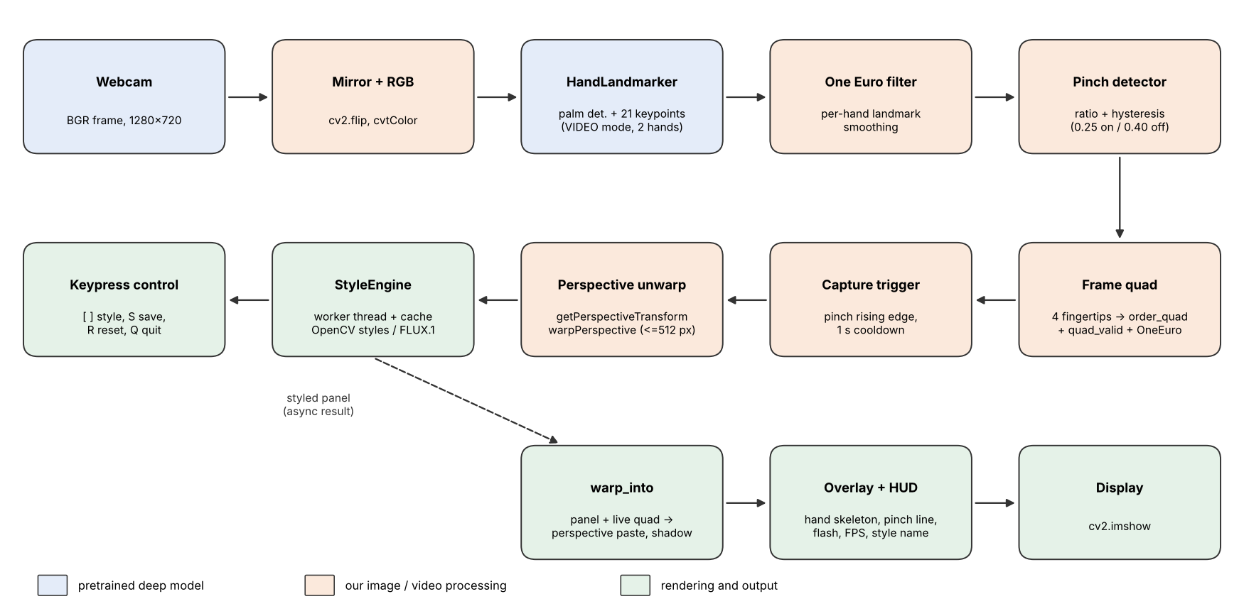
Fig. 1. Block diagram of the HandFrame AI processing pipeline. Blue = pretrained deep model, orange = our image/video processing, green = rendering and output. In VIDEO mode the landmark stage tracks each hand from the previous frame, so palm detection only runs again when tracking is lost.

A. Pipeline steps
- Acquire a frame from the webcam (1280x720 requested) and mirror it horizontally so that it behaves like a mirror. A clean copy is kept for capture, because overlays are drawn on the displayed frame only.
- Detect and track hands. The frame is converted from BGR to RGB and passed to the MediaPipe Hand Landmarker in VIDEO mode with a strictly increasing millisecond timestamp (detection confidence 0.6, presence and tracking confidence 0.5, at most 2 hands).
- Map and smooth. Normalised landmarks are scaled to pixel coordinates. If both hands are reported with the same handedness label, the second is relabelled so the two can be told apart. Each hand has its own One Euro filter; its state is reset if the hand was missing for more than 0.3 s.
- Extract features. The pinch ratio is the thumb-tip to index-tip distance divided by the palm length (wrist to middle-finger MCP). A hysteresis threshold turns it into a Boolean pinch state per hand. The four frame corners are the thumb and index tips of the two hands.
- Build the frame. The four corners are ordered (top-left, top-right, bottom-right, bottom-left), checked for validity (convex, each side at least 70 px, area at least 2% of the frame, aspect ratio at most 4) and smoothed by a second One Euro filter. The last 8 valid quadrilaterals are stored.
- Capture. On the rising edge of a pinch (with both hands present and a 1 s cooldown since the last capture), the oldest stored quadrilateral, from before the fingers closed, is used to rectify the clean frame with a perspective transform.
- Stylise. The capture is submitted to the StyleEngine, which returns the styled image asynchronously and caches it per (capture, style).
- Compose and display. The styled panel is warped back into the live frame inside the current quadrilateral with a drop shadow and white border (or shown as a corner thumbnail when the hands are lowered). The hand skeleton, pinch line, white capture flash, FPS counter and HUD are drawn on top.

B. Algorithm (pseudocode of the main loop)
for each camera frame F:
F <- flip(F, horizontal); clean <- copy(F)
hands <- HandLandmarker.detect_for_video(F) # <= 2 hands, 21 pts each
for each hand h:
h.pts <- OneEuro(h.pts) # per-hand smoothing
ratio <- |pts[4] - pts[8]| / max(|pts[0] - pts[9]|, 1)
h.pinch <- ratio < (0.40 if h.pinch_prev else 0.25) # hysteresis
any_pinch <- OR over hands of h.pinch
if len(hands) == 2:
if any_pinch and history not empty:
quad <- history[0] # hold frame steady while pinching
else:
raw <- order_quad(thumb_0, index_0, thumb_1, index_1)
if quad_valid(raw):
quad <- OneEuro(raw); history.append(quad) # keeps last 8
elif time since last valid quad > 0.3 s:
quad <- None; reset filter; clear history
if any_pinch rising edge and len(hands) == 2 and history and cooldown over:
capture <- unwarp(clean, history[0]) # perspective rectification
StyleEngine.request(capture, style_index) # worker thread
panel <- StyleEngine.get(capture, style_index) # None while still processing
if quad and panel: F <- warp_into(F, panel, quad)
elif quad: draw quad and "pinch to capture"
elif panel: draw corner thumbnail
draw hand skeletons, flash, HUD; imshow(F)
keys: [ ] change style | S save | R reset | Q quit

VI. Techniques / Algorithms Used

A. Image processing techniques
- Colour-space conversion: OpenCV delivers BGR frames; they are converted to RGB for the landmark model. Several styles work in other spaces: grayscale (pencil, noir, thermal), HSV (saturation and brightness boost in cartoon, anime, pop art, halftone, mosaic) and an RGB sepia matrix (vintage film) [5].
- Geometric transformations: horizontal mirroring (x' = W - 1 - x) gives selfie view. A perspective (homography) transform maps the four hand-defined corners to an upright rectangle (cv2.getPerspectiveTransform, cv2.warpPerspective with bicubic interpolation) [6], [9]. The inverse mapping warps the styled panel back into the frame with bilinear interpolation, and the same transform is applied to a white mask so the panel blends only inside the quadrilateral. The output size keeps the quadrilateral's aspect ratio, with the long side limited to 512 px.
- Deep-learning detection of the hand: a single-shot palm detector (BlazePalm, SSD-style) finds the hand, then a regression CNN outputs 21 keypoints; the palm is detected rather than the whole hand because it has a stable, nearly rigid shape [1], [3].
- Feature extraction: the pinch ratio r = ||tip4 - tip8|| / ||wrist - MCP9|| divides the thumb-index gap by the palm length, so it does not depend on how far the hand is from the camera. The frame corners are simply the thumb and index fingertip coordinates, ordered by the sum and difference of their coordinates.
- Thresholding with hysteresis: a pinch switches on below r = 0.25 and off only above r = 0.40. The dead band between the two thresholds prevents flicker when the fingers hover near the limit.
- Geometric validation: a candidate frame is accepted only if it is convex (cv2.isContourConvex), has sides of at least 70 px, an area of at least 2% of the image and a longest-to-shortest side ratio of at most 4.
- Filtering and smoothing (spatial): the 16 stylers use Gaussian, median, bilateral and mean-shift filtering [12], [14], domain-transform stylisation and pencil sketch [13], adaptive thresholding and Canny edge detection [15], dilation and erosion, and colour maps (cool, inferno), as listed in Table II.
TABLE II. The 16 style presets and the main operations behind each OpenCV stylizer.
# | Style | Main operations
1 | Pencil Sketch | Grayscale, inverted Gaussian blur, colour-dodge divide
2 | Color Pencil | cv2.pencilSketch (edge-preserving filter)
3 | Cartoon | 3x bilateral filter, colour quantisation, adaptive-threshold edges
4 | Anime | Mean-shift filtering, 6-level quantisation, HSV boost, eroded edge lines
5 | Oil Painting | cv2.stylization (sigma_s 70, sigma_r 0.55)
6 | Watercolor | cv2.stylization plus Gaussian-blurred paper texture blend
7 | Pop Art | Bilateral filter, 4-level quantisation, strong HSV saturation boost
8 | Neon Glow | Canny edges, dilation, cool colour map, Gaussian glow
9 | Comic Halftone | Down-sample to cells, draw dots scaled by darkness
10 | Cyberpunk | Per-channel gains, cyan Canny edges, glow
11 | Vaporwave | Pink-to-cyan vertical gradient blended with grayscale
12 | Vintage Film | Sepia matrix, Gaussian noise, vignette
13 | Film Noir | CLAHE [16], contrast stretch, strong vignette
14 | Pixel Art | 12x down-sample, 6-level quantisation, nearest-neighbour up-sample
15 | Mosaic | 18 px cells, HSV boost, dark grout lines
16 | Thermal | Blur, histogram equalisation, inferno colour map

B. Video processing techniques
- Frame acquisition and timestamping: frames are read continuously from cv2.VideoCapture. The landmarker in VIDEO mode requires strictly increasing timestamps, so the millisecond time is forced to be at least the previous value plus one.
- Object tracking: in VIDEO mode the landmark model uses the previous frame's landmarks to predict the next region of interest, so the costly palm detector is not run on every frame [1]. Hands are associated across frames by their handedness label, with duplicate labels resolved.
- Temporal smoothing with the One Euro filter: a low-pass filter whose cut-off rises with the speed of the signal [7]. For a sample x at time t with time step dt, the smoothing factor and filtered output are:
\hat{\dot{x}}_t = \alpha_d\,\dot{x}_t + (1-\alpha_d)\,\hat{\dot{x}}_{t-1},\qquad f_c = f_{c,\min} + \beta\,\lVert\hat{\dot{x}}_t\rVert

\alpha = \frac{1}{1 + \tau/dt},\quad \tau = \frac{1}{2\pi f_c},\qquad \hat{x}_t = \alpha\,x_t + (1-\alpha)\,\hat{x}_{t-1}
Hand landmarks use f_c,min = 1.5 Hz and beta = 0.02; the frame quadrilateral uses f_c,min = 1.2 Hz and beta = 0.01 (a little more smoothing, because the frame is the larger and more visible object). Slow, precise movements are smoothed strongly and fast movements follow with little lag.
- Temporal state handling: a hand not seen for 0.3 s has its filter and pinch state reset. The frame quadrilateral survives short dropouts for 0.3 s, and the last 8 clean quadrilaterals are stored so that the frame can be frozen at its pre-pinch position when the fingers close (closing the fingers moves the very landmarks that define the corners).
- Edge-triggered events and cooldown: a capture fires only on the rising edge of the pinch and not within 1 s of the previous capture, so holding a pinch does not trigger repeated captures.
- Compositing: the styled panel is blended with the live frame using a warped alpha mask; a blurred, offset copy of the quadrilateral darkens the frame to produce a drop shadow; a polyline draws the border. A decaying white flash (alpha 0.8 reduced by 0.1 per frame) confirms a capture.
- Asynchronous processing: a one-worker thread pool runs the styler, a lock protects a cache keyed by (capture, style), and the main loop dims the capture to half brightness while the result is still pending. Styles already generated are re-used instantly when the user cycles back to them.

VII. Implementation
TABLE III. Implementation environment.
Item | Details
Programming language | Python 3 (project developed and run on Python 3.13)
Core libraries | OpenCV (>= 4.9) [8] for capture, filtering, geometry and display; NumPy (>= 1.26); MediaPipe Tasks Vision (>= 0.10.14) for the Hand Landmarker
Optional libraries | PyTorch, diffusers (FluxImg2ImgPipeline), transformers, accelerate, sentencepiece, protobuf, Pillow for the FLUX.1 backend
Pretrained models | hand_landmarker.task (float16, 7.8 MB, bundled in models/, auto-downloaded if missing); FLUX.1-schnell from Hugging Face (optional)
Evaluation tools | The project's own modules driven by a Python script; Matplotlib and scikit-image sample data for figures; measured with OpenCV 5.0.0, NumPy 2.5.3, MediaPipe 0.10.32
Hardware | Any laptop or desktop with a webcam. Evaluation ran on a 2-core CPU-only Linux virtual machine without a camera or GPU
Code size | 738 lines of Python in 7 modules: app.py 169, styles.py 187, hand_tracker.py 117, inference.py 97, perspective.py 74, ui_overlay.py 60, smoothing.py 34

A. Module structure
- hand_tracker.py wraps the MediaPipe Hand Landmarker. It downloads the model if needed, runs detection in VIDEO mode, relabels duplicate handedness, smooths landmarks per hand, computes the pinch ratio and hysteresis state, and returns Hand objects (label, 21 smoothed landmarks, pinch ratio, pinch flag) sorted left to right.
- smoothing.py implements the One Euro filter used for both landmarks and the frame quadrilateral.
- perspective.py holds order_quad, quad_size, quad_valid, unwarp (rectify) and warp_into (paste back with shadow and border), plus a centre-crop that keeps the panel's aspect ratio equal to the quadrilateral's.
- styles.py defines 16 Style presets. Each stores a name, a FLUX.1 prompt, an img2img strength (0.6 to 0.8) and an OpenCV fallback function.
- inference.py is the StyleEngine: a one-worker thread pool, a lock-protected cache keyed by (capture id, style index), a pending set to avoid duplicate jobs, lazy loading of FLUX.1 on the first capture, and automatic fallback to OpenCV if FLUX is unavailable or fails.
- ui_overlay.py draws the hand skeleton (21 landmarks, 21 connections), highlighted thumb and index tips, the pinch line, the frame outline, the capture flash, the corner thumbnail and the HUD.
- app.py is the main loop that ties everything together and handles command-line options (--camera, --width, --height, --no-mirror, --flux, --model_path, --hand_model, --flux_size, --flux_steps).

B. Important implementation steps
- Open the camera and request 1280x720; exit with a message if it cannot be opened.
- Create the HandTracker (model auto-download) and the StyleEngine (OpenCV or FLUX mode).
- For every frame, mirror it, run detection, and update the frame quadrilateral and pinch state as in Section V.
- On a capture, rectify the clean frame, submit it to the StyleEngine and flash the screen.
- Each frame, fetch the styled result if it is ready; otherwise show the dimmed capture and re-submit if needed.
- Handle keys: ] or D next style, [ or A previous style (the current capture is restyled), S saves the styled result as a PNG in captures/, R resets, Q or Esc quits.
- On exit, release the camera, close the landmarker, shut down the worker pool and destroy the window.

C. Optional FLUX.1 backend
With the --flux option or --model_path, StyleEngine loads FLUX.1-schnell through diffusers' FluxImg2ImgPipeline [11]. The capture is resized so the long side is 512 px (a multiple of 16), then run with the style's text prompt, the style's strength, 8 inference steps and guidance scale 0. The model uses bfloat16 on CUDA or Apple MPS and float32 on CPU, with model CPU offload on CUDA. If loading fails the status line shows "FLUX failed" and the OpenCV styles are used instead.

VIII. Results and Discussion

A. What was measured
No webcam or hand photographs were available in the evaluation environment, so the numbers below test each processing stage of HandFrame AI with controlled inputs. They do not measure end-to-end gesture accuracy on real users. Every number was produced by running the project's own modules (styles.py, perspective.py, smoothing.py, hand_tracker.py, ui_overlay.py) on the inputs listed in Table I.
[Insert your own screenshots here from a live run: (a) both hands forming the frame with the "pinch to capture" hint, (b) the styled panel floating inside the frame, (c) the same capture in two or three different styles.]

B. Style outputs and style run time
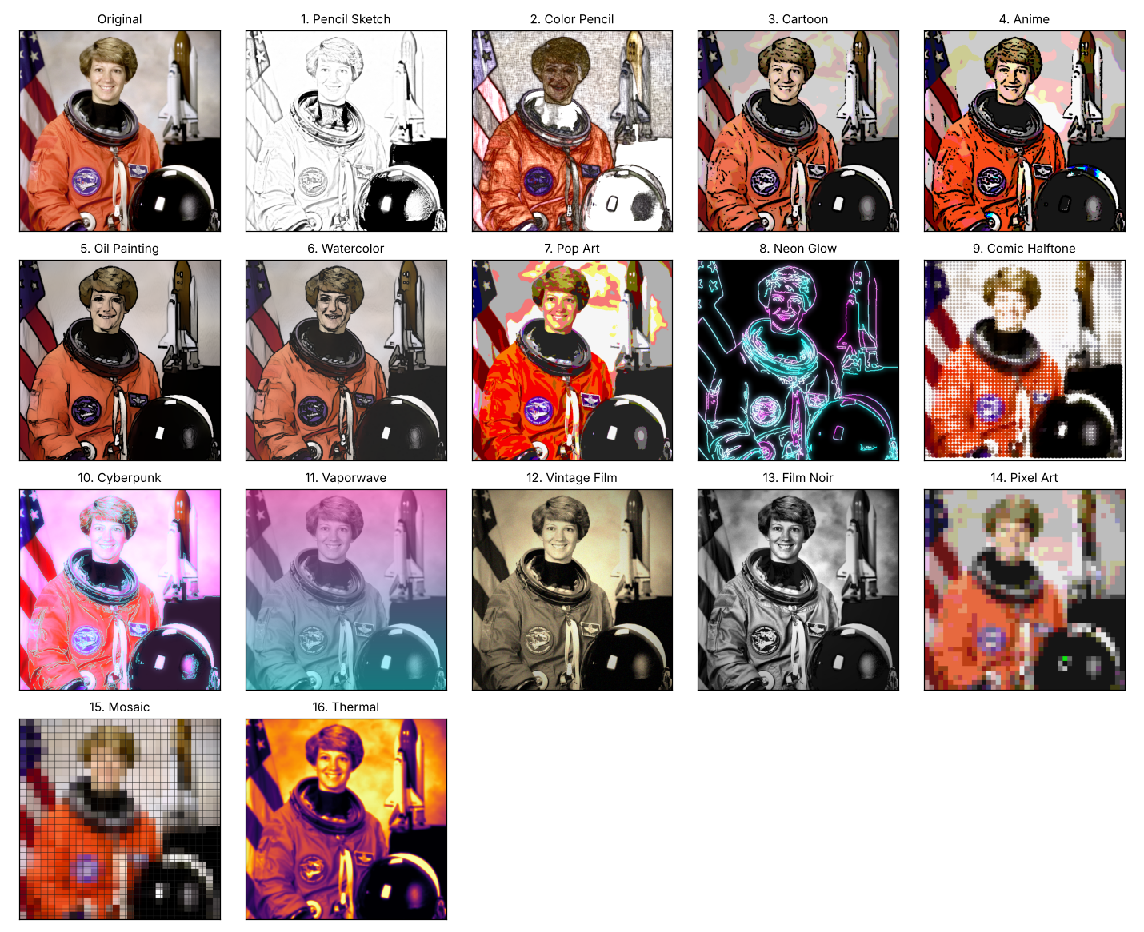
Fig. 2. The original capture (sample portrait) and the output of each of the 16 OpenCV style presets (numbers match Table II).
All 16 stylers returned an image of the same size and type as the input. Run times (median of 5 runs per style on a 512x512 capture, 2-core CPU) are shown in Fig. 3. The median style takes 15 ms. Thirteen styles finish in under 100 ms; the slowest are Anime (425 ms, mean-shift filtering), Watercolor (191 ms) and Oil Painting (190 ms), both based on cv2.stylization. Pixel Art, Thermal and Mosaic take about 1 ms. These differences are why styling runs on a worker thread: the slow styles would otherwise freeze the video for several frames.
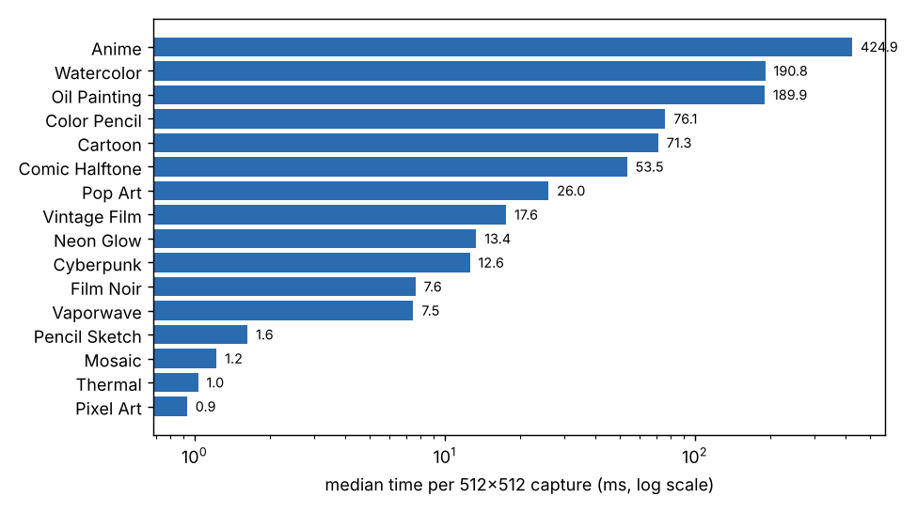
Fig. 3. Median time of each OpenCV styler on a 512x512 capture (log scale).

C. Frame geometry and perspective rectification
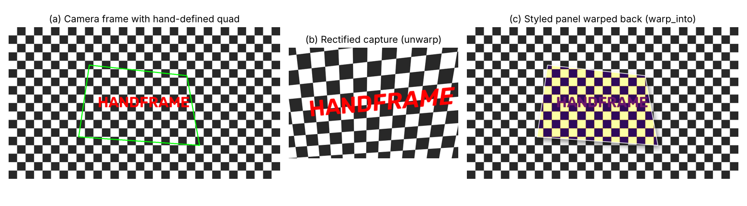
Fig. 4. (a) A synthetic 1280x720 camera frame with a skewed quadrilateral standing in for the four fingertips; (b) the rectified capture from unwarp; (c) a styled panel (thermal colour map) pasted back by warp_into with border and shadow.
TABLE IV. Geometry checks on the synthetic frame.
Check | Result
order_quad given the four corners in shuffled order | Original corner order recovered exactly
quad_valid on the test quadrilateral (about 520 x 340 px) | Accepted
quad_valid on a 40 x 40 px quadrilateral | Rejected (minimum side 70 px)
quad_valid on a self-crossing (bow-tie) quadrilateral | Rejected (not convex)
Capture size produced by unwarp | 512 x 336 px (aspect ratio of the quadrilateral kept)
Mean absolute error after unwarp then warp back (inside the quadrilateral, 0 to 255 scale) | 5.3 grey levels, on a checkerboard whose sharp edges are the hardest case for resampling
unwarp run time | 1.9 ms
warp_into run time (1280x720 frame, with shadow) | 37 ms
The ordering, validation and rectification behave as designed. The remaining error comes from resampling the image twice (bicubic to rectify, bilinear to paste back) and is concentrated at the checkerboard edges.

D. Landmark and frame smoothing
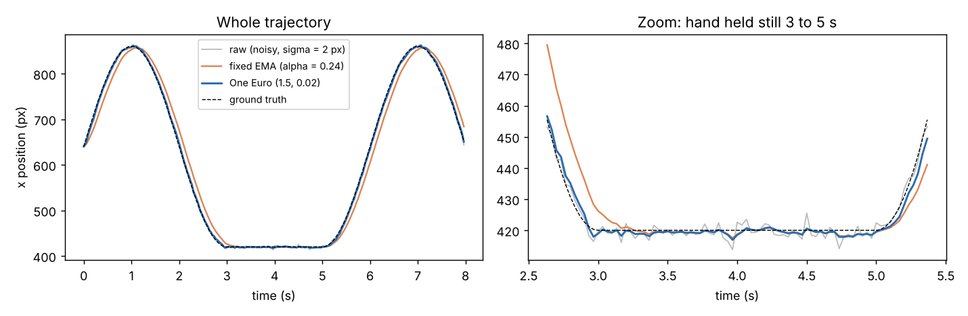
Fig. 5. A simulated hand track (x coordinate) with 2 px Gaussian noise: raw signal, a fixed exponential moving average (alpha = 0.24, the One Euro filter's low-speed factor), and the One Euro filter with the hand-tracker settings. The hand pauses between 3 s and 5 s.
TABLE V. Smoothing results (mean of 20 random noise realisations, 240 frames at 30 fps, sigma = 2 px).
Signal | Jitter while still (px) | RMS error while moving (px)
Raw landmarks | 1.89 | 2.81
One Euro, hand settings (1.5, 0.02) | 0.71 | 5.45
One Euro, frame-quad settings (1.2, 0.01) | 0.60 | 8.19
Fixed EMA, alpha = 0.24 | 0.60 | 32.2
The One Euro filter cuts jitter while the hand is still by 62% (1.89 px to 0.71 px). A fixed filter with the same low-speed smoothing reaches a similar jitter level, but it lags a moving hand by 32 px RMS, against 5.4 px for the One Euro filter. The raw signal has the lowest error while moving only because it is not smoothed at all; its 1.9 px jitter would make the frame shake visibly. The frame quadrilateral uses stronger smoothing (8.2 px RMS error while moving) because a trembling frame is more noticeable than a slightly delayed one.

E. Pinch detection stability
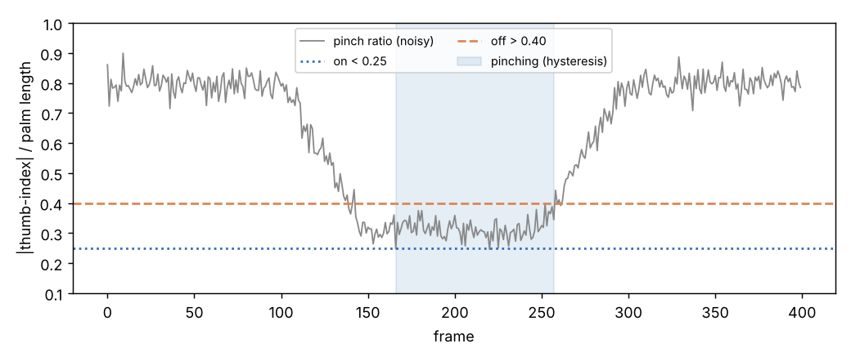
Fig. 6. A simulated pinch: the ratio falls from 0.8 to about 0.3, stays there with noise (sigma = 0.03), and rises again. The shaded region is the pinch state produced by the hysteresis thresholds (on below 0.25, off above 0.40).
Over 400 frames, a single fixed threshold at 0.30 changed state 50 times, because the noisy ratio kept crossing it. The hysteresis detector changed state twice (one press, one release). Because the ratio is divided by the palm length, the same thresholds apply whether the hand is near the camera or far from it.

F. Timing summary
TABLE VI. Timing measurements (2-core CPU, no GPU).
Stage | Measured | Notes
Hand Landmarker, 1280x720 frame | 14.9 ms median (95th percentile 20.2 ms) | 40 runs on a frame without a hand, so this is the detection path; the time with a tracked hand was not measured
OpenCV style, 512x512 capture | 15.5 ms median (0.9 to 425 ms) | Runs on the worker thread, not in the video loop
unwarp (rectify) | 1.9 ms | Once per capture
warp_into (paste back with shadow) | 37 ms | Every frame while a panel is shown
Hand overlay and HUD drawing | 1.8 ms | Two hands plus HUD
While a panel is displayed, the per-frame cost is dominated by warp_into: about 15 ms for detection, 37 ms for compositing and 2 ms for drawing add up to roughly 54 ms, or about 18 frames per second on this machine. This is an estimate from the stage timings, not a measured end-to-end frame rate. A faster CPU, a smaller frame size (the --width and --height options) or a cheaper shadow would raise it.

IX. Challenges / Limitations
- Jitter versus latency: raw landmarks jump by a few pixels every frame. The One Euro filter, hysteresis, the 0.3 s grace period and the capture cooldown solve this, but each adds some delay. In the simulation the frame-quad filter trailed a moving hand by 8.2 px RMS (Table V).
- The pinch moves the frame corners: the fingertips that define the frame are the same ones that close in a pinch, so the corners shift just as the user captures. The application freezes the frame at the oldest of the last 8 clean quadrilaterals (about 0.27 s at 30 fps), which means the capture is slightly older than the instant of the pinch.
- Visibility and lighting: the frame needs the thumb and index finger of both hands to be seen. Hands that overlap, leave the picture or are poorly lit are not tracked, and if only one hand is visible the frame disappears after 0.3 s. Behaviour under low light, noise and motion blur was not measured here.
- Planar approximation: the four fingertips are at different distances from the camera, so the "frame" is a 2D quadrilateral; the perspective transform is exact only for a flat surface. A single RGB camera gives no reliable depth, so strongly tilted hands give a distorted capture.
- Handedness errors: the model can label both hands the same side. The tracker relabels the second hand, but the label may swap briefly and reset a hand's filter.
- Style quality and speed: the OpenCV styles are fast but are filters, not true style transfer. The slowest (Anime 425 ms) takes several frame times, and results are shown only when ready (the capture is dimmed meanwhile). The FLUX.1 backend gives better results but needs a strong GPU, a large first-time download and noticeably longer processing per image. The FLUX prompts add "portrait of the same person", so they suit portraits better than landscapes or objects.
- Compositing cost: warp_into takes 37 ms per frame at 1280x720 on our CPU, which limits the frame rate to roughly 18 fps there.
- Evaluation limits: the tests use one sample portrait, synthetic frames and simulated noise, no real hands, and no user study. The thresholds (pinch 0.25 and 0.40, minimum frame side 70 px, area 2%, aspect 4) are fixed and may need tuning for different hand sizes and camera positions.
- Accidental triggers: a pinch by either hand captures while two hands are present, so a casual pinch can capture an unintended frame; the 1 s cooldown only limits repeats.

X. Conclusion
What was implemented. HandFrame AI is a Python application in which two hands form a floating frame, a pinch captures the framed region, and the capture is instantly restyled in one of 16 styles and displayed back inside the live video. It combines a pretrained hand-landmark model with our own geometric, filtering and compositing code in about 740 lines.
Techniques used. Mirroring and colour conversion, CNN-based palm detection and landmark regression, scale-invariant feature extraction (pinch ratio), geometric validation of the frame, hysteresis thresholding, One Euro temporal filtering, perspective rectification and warp-back, alpha compositing with a shadow, edge-triggered capture with cooldown, asynchronous processing with caching, and a set of classical filters (bilateral, mean-shift, Canny, adaptive threshold, CLAHE, colour maps) for the styles.
What was achieved. In controlled tests, the 16 OpenCV styles ran in a median of 15 ms per capture, the One Euro filter reduced jitter on a still hand by 62% while following a moving hand six times more closely than a fixed filter of equal smoothing, hysteresis cut pinch state changes on a noisy signal from 50 to 2, and the quadrilateral ordering, validation and rectification behaved correctly. Detector time on the evaluation CPU was about 15 ms per 720p frame.
What we learned. A strong pretrained detector solves only part of the problem. Turning its noisy output into a usable interface depends on classical image and video processing: normalising features so they do not depend on distance, choosing thresholds with a dead band, and filtering over time. Every stabilising step trades smoothness against latency, and measuring this rather than assuming it was one of the most useful parts of the project.
Future work. Test with real hands, recorded camera footage and a user study; add gestures for changing style (for example a swipe) so that no keyboard is needed; use the 3D landmarks to handle tilted hands; adapt thresholds per user; reduce the compositing cost; capture short clips as well as stills; and tune the FLUX.1 prompts for non-portrait scenes.

References
- F. Zhang, V. Bazarevsky, A. Vakunov, A. Tkachenka, G. Sung, C.-L. Chang and M. Grundmann, "MediaPipe Hands: On-device real-time hand tracking," in Proc. CVPR Workshop on Computer Vision for AR/VR, 2020. arXiv:2006.10214.
- C. Lugaresi et al., "MediaPipe: A framework for building perception pipelines," 2019, arXiv:1906.08172.
- V. Bazarevsky, Y. Kartynnik, A. Vakunov, K. Raveendran and M. Grundmann, "BlazeFace: Sub-millisecond neural face detection on mobile GPUs," 2019, arXiv:1907.05047.
- Google AI Edge, "Hand landmarks detection guide," MediaPipe Solutions. [Online]. Available: https://ai.google.dev/edge/mediapipe/solutions/vision/hand_landmarker
- R. C. Gonzalez and R. E. Woods, Digital Image Processing, 4th ed. New York, NY, USA: Pearson, 2018.
- R. Szeliski, Computer Vision: Algorithms and Applications, 2nd ed. Cham, Switzerland: Springer, 2022.
- G. Casiez, N. Roussel and D. Vogel, "1 Euro filter: A simple speed-based low-pass filter for noisy input in interactive systems," in Proc. ACM CHI, 2012, pp. 2527-2530.
- G. Bradski, "The OpenCV library," Dr. Dobb's Journal of Software Tools, vol. 25, no. 11, pp. 120-125, 2000.
- R. Hartley and A. Zisserman, Multiple View Geometry in Computer Vision, 2nd ed. Cambridge, U.K.: Cambridge Univ. Press, 2003.
- S. S. Rautaray and A. Agrawal, "Vision based hand gesture recognition for human computer interaction: A survey," Artif. Intell. Rev., vol. 43, no. 1, pp. 1-54, 2015.
- Black Forest Labs, "FLUX.1 [schnell]," Hugging Face model card. [Online]. Available: https://huggingface.co/black-forest-labs/FLUX.1-schnell
- C. Tomasi and R. Manduchi, "Bilateral filtering for gray and color images," in Proc. IEEE ICCV, 1998, pp. 839-846.
- E. S. L. Gastal and M. M. Oliveira, "Domain transform for edge-aware image and video processing," ACM Trans. Graph., vol. 30, no. 4, art. 69, 2011.
- D. Comaniciu and P. Meer, "Mean shift: A robust approach toward feature space analysis," IEEE Trans. Pattern Anal. Mach. Intell., vol. 24, no. 5, pp. 603-619, 2002.
- J. Canny, "A computational approach to edge detection," IEEE Trans. Pattern Anal. Mach. Intell., vol. PAMI-8, no. 6, pp. 679-698, 1986.
- K. Zuiderveld, "Contrast limited adaptive histogram equalization," in Graphics Gems IV, P. S. Heckbert, Ed. San Diego, CA, USA: Academic Press, 1994, pp. 474-485.

